# Python

Install python 3.10 from the Microsoft store, this can be accessed from the search function in the taskbar.

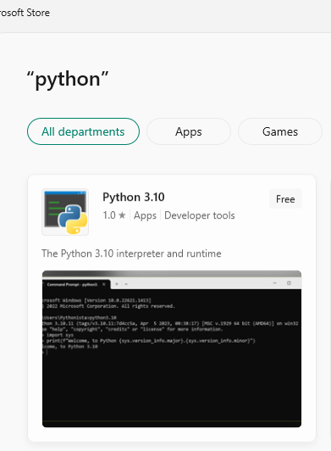

# Visual Studio Code

Visual Studio Code can be downloaded online from their official website (Install the 64-bit windows version) and follow with the recommended add-ons. (https://code.visualstudio.com/)

# Setting up Python in Visual Studio

After installing the visual studio code open the app and go to the bottom right corner of the app.

Please press on select language model (Note that in the above picture it is currently Python 3.10.11 64-bit Microsoft store)

Next, a pop-up should appear at the top of the screen and choose the python interpreter.

With this Visual Studio Code should be able to run python code.

# Terminal

Next open the file containing the code from the top right corner. File-> Open Folder.

This should open a new tab with the R_Create.py, R_Delete.py and Read Me folder.

This should also open up a python debug terminal at the bottom of the screen.

If this does not occur, you can upon up a terminal from the top left of the tab. Terminal->New Terminal.

# Libraries

Following libraries are needed to run the code: pandas and win32com.

These can be installed by using the following commands in the visual studio code terminal which should be a python debug console:

pip install pandas

pip install pywin32

pip install openpyxl

pip install jinja2

Please input one line at a time.

# Documentation

To run this code, first add the csv file inside the folder such as:

Make sure the csv file is called **Book1.csv.**

Next run the R_Create.py file by clicking once on it and afterwards press ctrl+f5 to run without debugging.

You will know that the run-time is done when the following disappears from the top of the tab:

The output should be 3 files containing the PRLU statistics, Customer Care statistics and the total numbers from both in Counter.

Finally delete the files using the R_Delete.py, this is important since it also removes junk files from the python folder, if this is not done the following code may not work due to file overload.

**Important:**

**Inside the R_Delete.py change line 12**

shutil.rmtree('C:/Users/<Insert>/AppData/Local/Temp/gen_py')

**Change from <Insert> to username on pc. Example bugel049**